SAS Basic Program

/\*Data Step\*/

data europeancars;

set sashelp.cars;

where origin="Europe";

run;

/\*Proc Step\*/

proc print data=europeancars;

run;

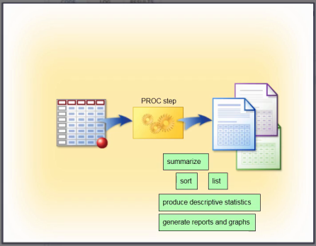

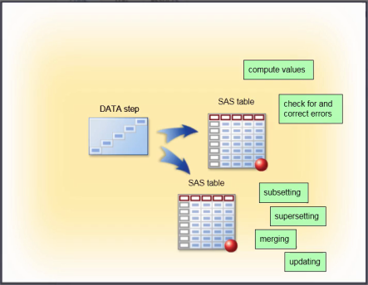

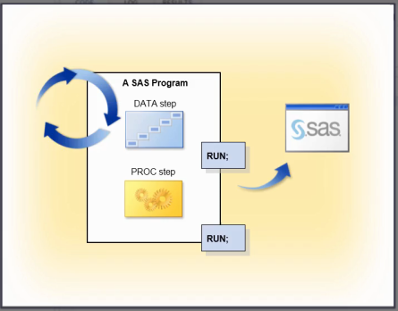

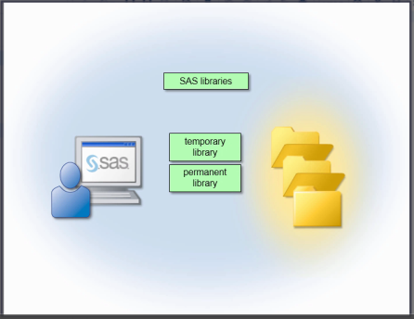

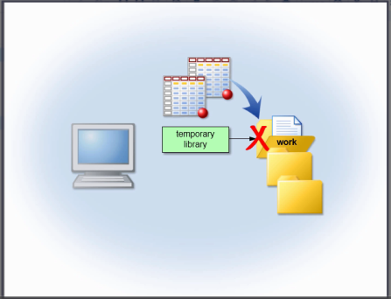

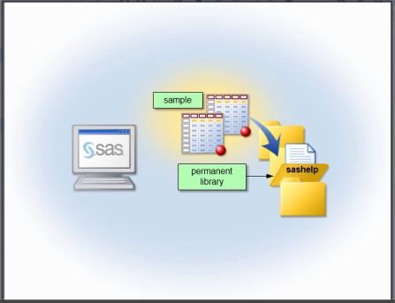

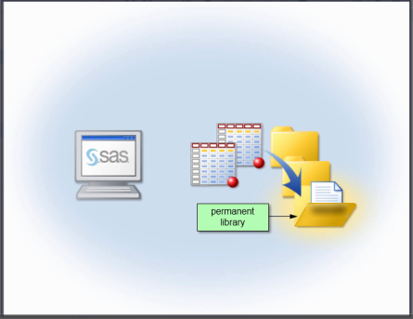

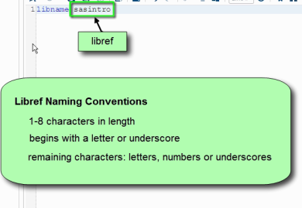

Naming Convention:

Column Name: 1-32 characters long

Must start with letter or underscore,

Uppercase lowercase or both

SAS columnnames are case insensitive;

